Deep breathing can help me feel better 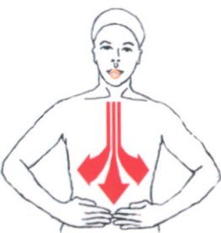

I can try:
- Bumblebee breathing 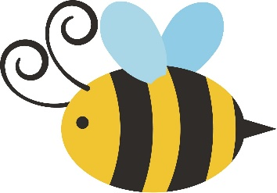
(Breathe in through nose and hum for out breath)

- Bubble breathing 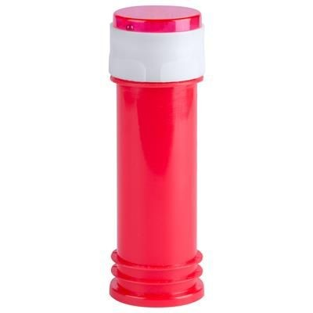
(breath in through nose and blow through wand to make bubbles)

- Belly breathing 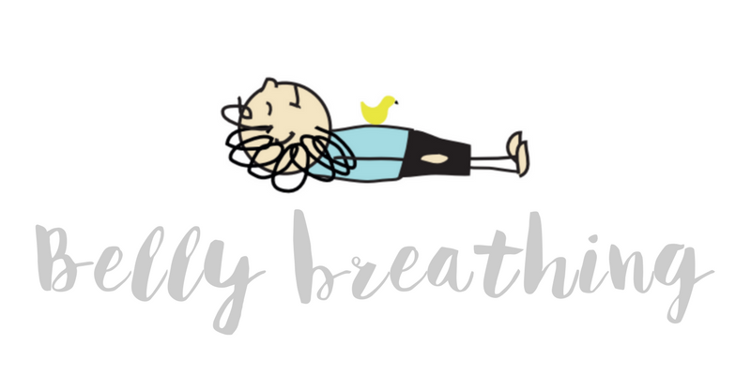
(lie on back with toy on belly and make toy move up and down with breath – breathe in, belly rises… breathe out, belly lowers)

